Nama : Dara Cantika Febrian Kinasih

Kelas : PPTI 21

NIM : 2802538460

**FONT**

<https://www.dafont.com/valorant.font>

**FIGMA**

Saya edit di canva

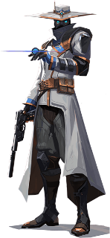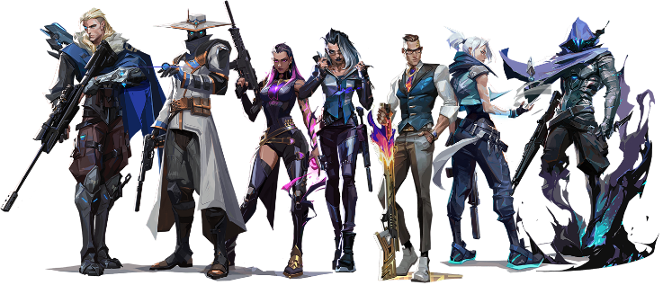

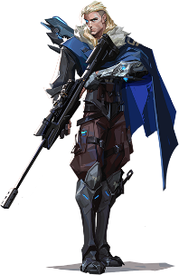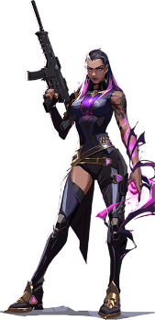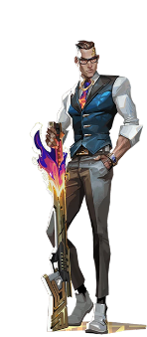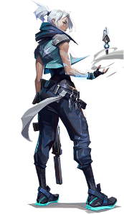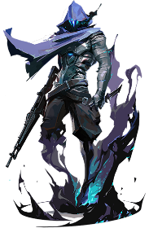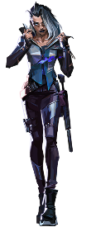

Link: <https://valorant-lore.fandom.com/wiki/Agents>

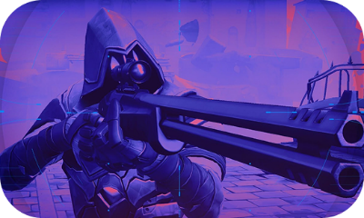

Link: <https://playvalorant.com/id-id/news/game-updates/a-new-addition-to-the-arsenal-outlaw-insights/>

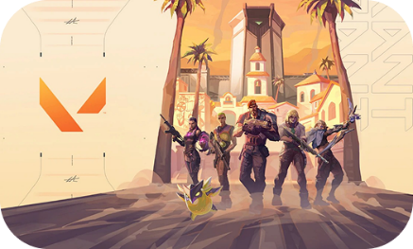

Link: <https://www.uhdpaper.com/2023/07/valorant-episode-7-act-2-reyna-4k-7921l.html>

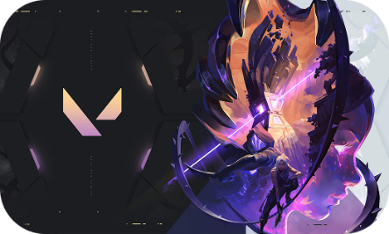

Link: <https://www.uhdpaper.com/2024/08/4932a-valorant-jett-omen-episode-9-4k.html>

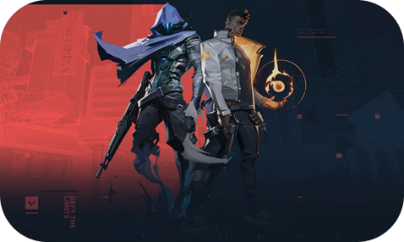

Link: <https://technobusiness.id/news/2020/10/15/riot-games-gelar-kompetisi-esports-tingkat-perguruan-tinggi/>

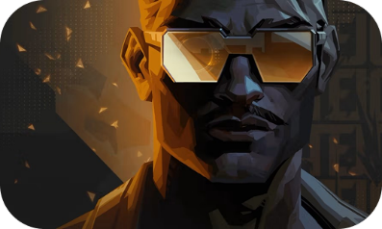

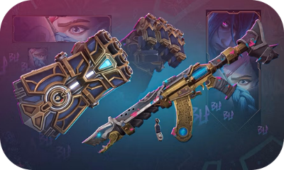Link: <https://playvalorant.com/en-gb/news/game-updates/tejo-man-of-action/>

Link: <https://www.riotgames.com/en/news/arcane-season-2-in-game-activations>

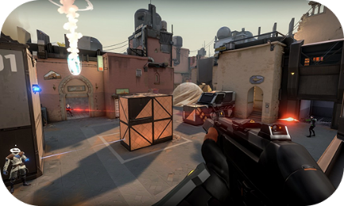

Link: <https://www.uhdpaper.com/2023/07/valorant-episode-7-act-2-reyna-4k-7921l.html>

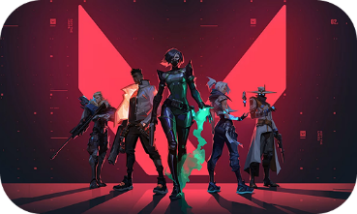Link: <https://playvalorant.com/en-us/media/>

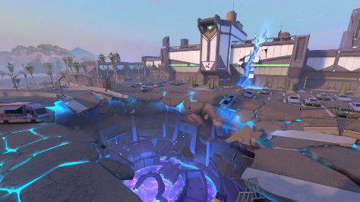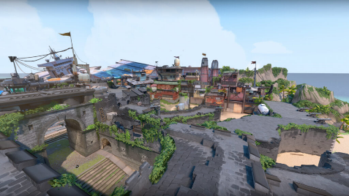

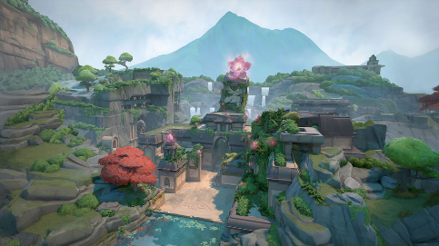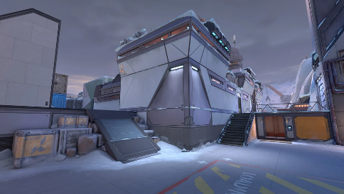

Link: <https://playvalorant.com/en-us/maps/>

**HTML**

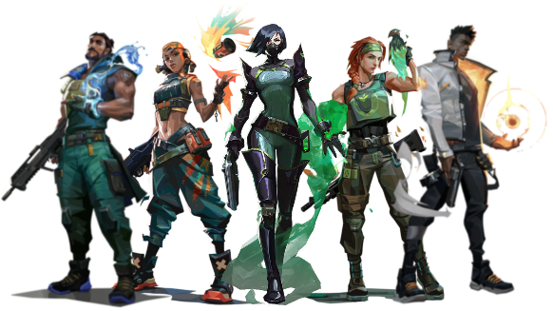

Saya edit di canva

Link: <https://valorant-lore.fandom.com/wiki/Agents>

Link: <https://wall.alphacoders.com/big.php?i=1315738>

Link: <https://wall.alphacoders.com/big.php?i=1295178>

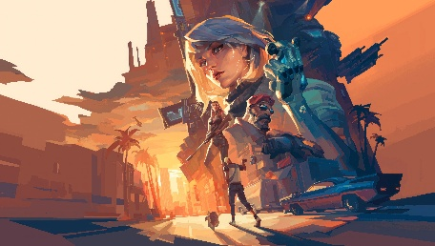

Link: <https://wall.alphacoders.com/big.php?i=1322753#google_vignette>

Link: <https://wall.alphacoders.com/big.php?i=1346952>

Saya edit di Figma

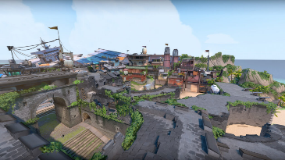

Link: <https://playvalorant.com/en-us/maps/>



Link: <https://icons8.com/icon/7fmeQ3hXsmSw/riot-games>

Untuk font nya saya edit di figma menggunakan font Valorant

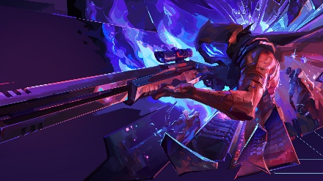

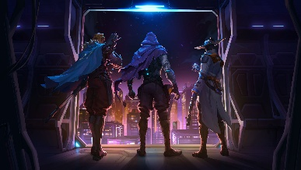

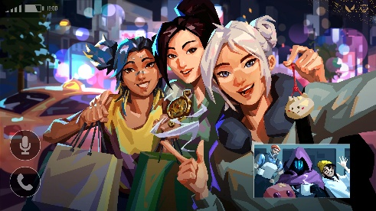

Link: <https://playvalorant.com/en-us/media/>



Link: <https://playvalorant.com/en-us/agents/viper/>

Untuk collage nya saya edit menggunakan figma



Link: <https://playvalorant.com/en-us/agents/skye/>

Untuk collage nya saya edit menggunakan figma



Link: <https://playvalorant.com/en-us/agents/harbor/>

Untuk collage nya saya edit menggunakan figma



Link: <https://playvalorant.com/en-us/agents/raze/>

Untuk collage nya saya edit menggunakan figma



Link: <https://playvalorant.com/en-us/agents/phoenix/>

Untuk collage nya saya edit menggunakan figma



<https://valorant.fandom.com/wiki/Agents/Controllers?file=ControllerClassSymbol.png>